T2.micro EC2 instance
Tasks
1.
Create a free AWS account (or use an existing one), launch a t2.micro EC2 instance, and open the AWS CloudWatch dashboard to verify that basic monitoring metrics like CPU utilization are visible for your instance.
2.
Set up a CloudWatch alarm that triggers when your EC2 instance's CPU utilization goes above 70% for 5 minutes, and configure it to send a notification to your email.<br><br><em><strong>Hint:</strong> Use the 'Create Alarm' option in CloudWatch, and select 'Send notification' as the action.</em>
3.
If you have access to Azure, create a storage account and use Azure Monitor to view metrics such as total requests and availability for that storage resource.
4.
Simulate a spike in CPU usage on your AWS EC2 instance (for example, by running a CPU stress tool or a loop in the terminal), and check CloudWatch to confirm the metric graph updates in near real-time.<br><br><em><strong>Hint:</strong> You can use the 'stress' command on Linux, or run a simple infinite loop script to increase CPU load.</em>
5.
Write a short comparison (3-4 points) of AWS CloudWatch vs Azure Monitor, focusing on how each handles monitoring for virtual machines and storage resources.

Answer : Task 1 — Launch an EC2 instance and view CloudWatch

Step 1: Create/sign in to AWS
- Go to AWS Console.
- Create a free AWS account if you don't already have one.
- Sign in to the AWS Management Console.
- In the search bar, type EC2 and open it.
Little info:
EC2 (Elastic Compute Cloud) is AWS's service for running virtual machines/servers in the cloud.

Step 2: Launch an EC2 instance
In the EC2 dashboard:
- Click Launch instance.
- Give it a name, for example:
CloudWatch-Demo
- Under Application and OS Images, choose Amazon Linux.
- Choose an image marked as Free tier eligible, if available.
- Under Instance type, select t2.micro if it is available and eligible for your account/region.
- Create/select a key pair if AWS asks you to.
- For the security group, you can leave the basic/default configuration for this monitoring exercise.
- Click Launch instance.
Wait until the instance shows Running.

Step 3: Open CloudWatch
- In the AWS search bar, search for CloudWatch.
- Open CloudWatch.
- Select All metrics.
- Look for the EC2 metrics.
- Select your instance.
You should be able to find metrics such as:
- CPUUtilization
- Network traffic
- Disk-related metrics depending on the monitoring configuration
Little info:
CloudWatch is AWS's monitoring service. It collects metrics from AWS resources and lets you create graphs, dashboards, and alarms.

What you need to show for Task 1
Take a screenshot showing:
EC2 instance → CloudWatch → CPUUtilization graph
That proves basic monitoring is working.

Task 2 — Create a CPU alarm
Now we'll create an alarm for:
CPU utilization > 70% for 5 minutes → email notification

Step 1: Open CloudWatch alarms
- Go to CloudWatch.
- On the left menu, select Alarms.
- Click Create alarm.
- Click Select metric.

Step 2: Select the EC2 CPU metric
Find:
EC2 → Per-Instance Metrics → CPUUtilization
Select your EC2 instance.
Then click Select metric.

Step 3: Configure the condition
Set:
- Statistic: Average
- Period: 5 minutes
- Threshold type: Static
- Condition: Greater than
- Threshold: 70
So the rule basically means:
"If the average CPU utilization is greater than 70% during a 5-minute period, trigger the alarm."

Step 4: Configure email notification
Under Alarm state trigger/action, select the option similar to:
Send notification
Create/select an SNS topic.
Enter your email address.
AWS will send a confirmation email.
Very important: Open that email and click the confirmation link. Otherwise, the notification may not be delivered.

Step 5: Name the alarm
For example:
EC2-CPU-Above-70
Click Create alarm.

What you should see
Initially the alarm will probably be:
OK
because your EC2 instance isn't using more than 70% CPU.
Little info:
An alarm watches a metric and changes state when a condition is met. CloudWatch can then send notifications or perform other actions.

Task 3 — Azure Storage + Azure Monitor
This task is optional if you don't have Azure access.
Go to Microsoft Azure Portal and sign in.

Step 1: Create a Storage Account
Search for:
Storage accounts
Click Create.
Choose:
- Subscription: your subscription
- Resource group: create a new one, e.g. monitoring-demo
- Storage account name: a unique name such as cloudmonitoringdemo123
- Region: choose an appropriate region
- Performance: Standard
- Redundancy: LRS is sufficient for a basic demonstration
Click Review + create, then Create.

Step 2: Open Azure Monitor
After the storage account is created:
- Open your storage account.
- Select Monitoring.
- Click Metrics.
You can explore metrics such as:
- Transactions / Total Requests
- Availability
- Ingress
- Egress
- Latency
Little info:
Azure Monitor is Microsoft's monitoring platform. It can monitor Azure virtual machines, storage, applications, and many other Azure resources.
For your assignment, take a screenshot showing the Metrics graph with a storage metric such as Total Requests or Availability.

Task 4 — Create CPU usage and watch CloudWatch
Now we're going to deliberately increase CPU usage.

Step 1: Connect to your EC2 instance
Go to:
EC2 → Instances → select your instance
Click Connect.
AWS provides several connection methods. If you're using an Amazon Linux instance, you can use EC2 Instance Connect if available.
Open the terminal.

Step 2: Generate CPU load
On Linux, you can use a simple loop.
For example:
while true; do :; done
This continuously performs work and should increase CPU usage.
If you have multiple CPU cores and want more load, you can open multiple terminal sessions and run the command.
Important: Don't leave this running after the experiment.
Stop it with:
Ctrl+C

Step 3: Watch CloudWatch
Go back to:
CloudWatch → Metrics → EC2 → CPUUtilization
Open the CPU graph.
You should see something similar to:
Normal CPU → CPU increases → CPU becomes high → CPU decreases
CloudWatch metrics don't necessarily update every second, so give it a little time.

Step 4: Check your alarm
Because you configured:
CPU > 70% for 5 minutes
you may see the alarm change from:
OK → ALARM
after the condition remains satisfied for the required period.
You may also receive the SNS email.

Task 5 — AWS CloudWatch vs Azure Monitor
For your assignment, you can use these four comparison points:
Feature | AWS CloudWatch | Azure Monitor
Virtual machines | Monitors EC2 instances using metrics such as CPU utilization, network activity, and status information. | Monitors Azure Virtual Machines using metrics such as CPU, disk, network, and availability.
Storage monitoring | Can monitor AWS storage services and related metrics through CloudWatch. | Provides metrics for Azure Storage, including requests, availability, latency, ingress, and egress.
Alerts | Uses CloudWatch Alarms to trigger notifications/actions when metric conditions are met. | Uses Azure Monitor alerts to notify users or trigger actions when defined conditions occur.
Integration | Works closely with AWS services such as EC2, S3, RDS, and SNS. | Works closely with Azure services such as Virtual Machines, Storage, App Services, and Log Analytics.

Simple conclusion
CloudWatch and Azure Monitor perform similar jobs, but they are designed primarily for their respective cloud platforms. CloudWatch is especially useful for monitoring AWS resources such as EC2, while Azure Monitor provides similar monitoring capabilities for Azure Virtual Machines and Storage Accounts. Both support metrics, graphs, alerts, and notifications.

📸 Screenshots I'd recommend taking
You can use these as your assignment evidence:
- EC2 instance running
- CloudWatch CPUUtilization graph
- CloudWatch alarm configuration showing >70% / 5 minutes
- SNS email confirmation or notification
- CPU spike visible in CloudWatch
- Azure Storage Metrics page — if doing Task 3
- Final comparison

One important cleanup step
When you're completely finished, go back to EC2 → Instances, select your test instance, and choose Terminate instance. Also check that you don't have unnecessary AWS resources such as unused Elastic IPs or other paid resources left running.
If you want, I can also guide you click-by-click through the AWS console starting from Task 1, and you can tell me what you see on each screen.

1. EC2 instance — what it should look like
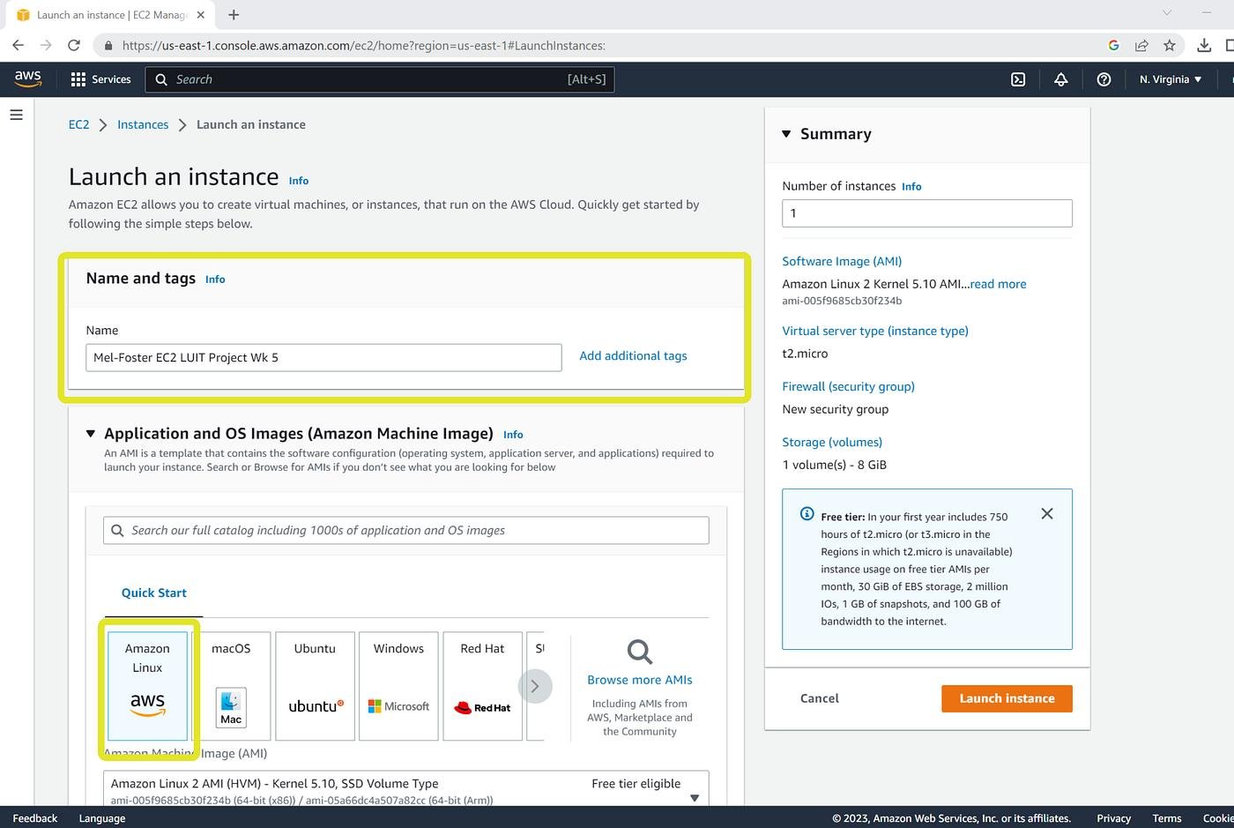
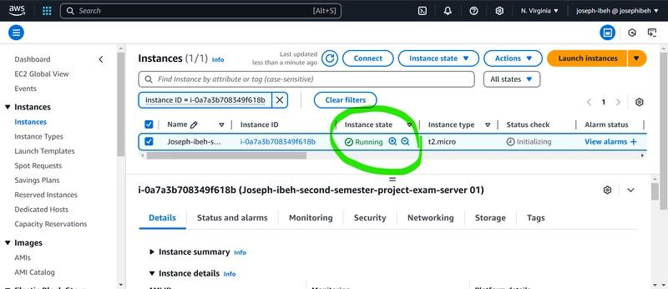
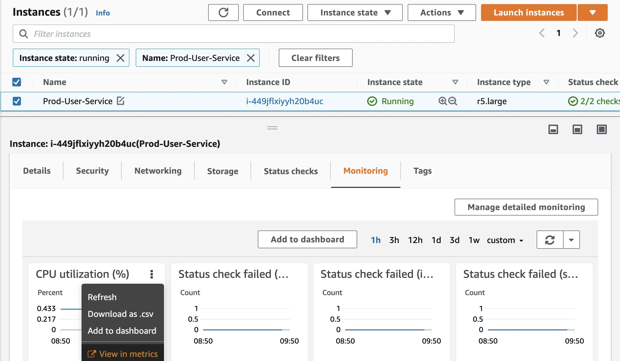
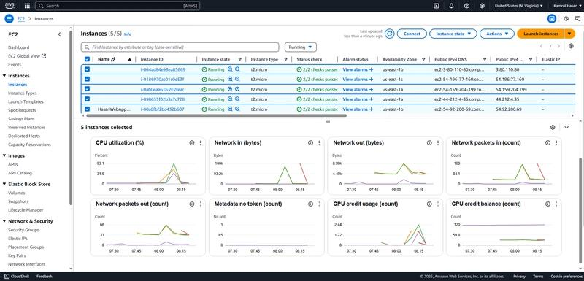
Example
After launching, you want something similar to:
EC2 → Instances

Name Instance type State
------------------------------------------------
CloudWatch-Demo t2.micro Running 🟢
What to look for:
- Instance state = Running
- Instance type = t2.micro
- Your instance has an Instance ID

2. CloudWatch CPU utilization
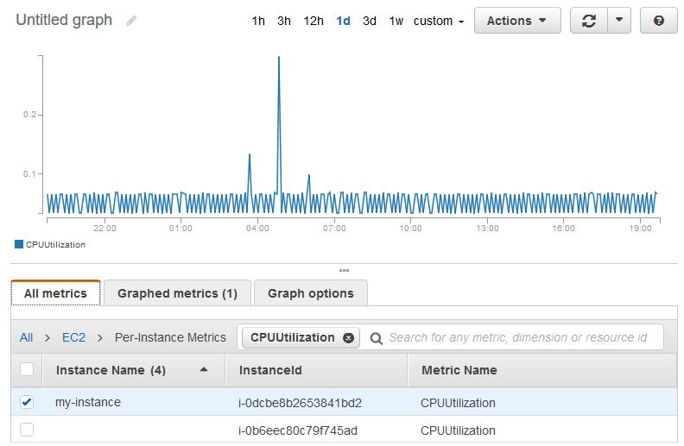
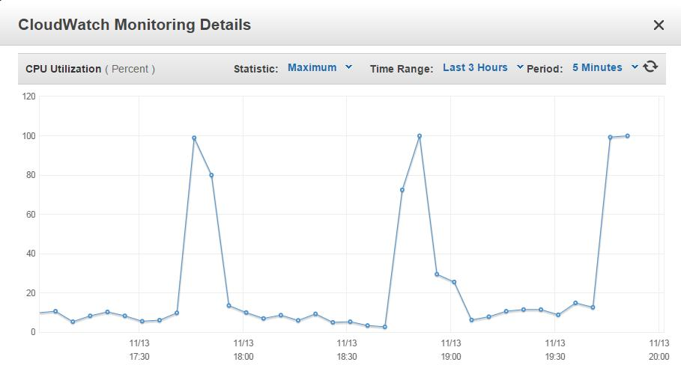
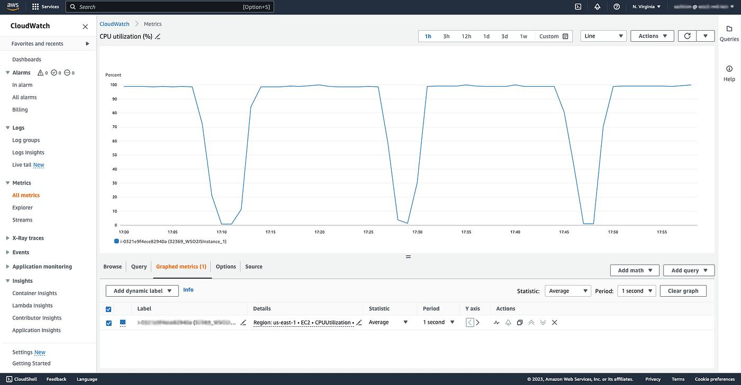
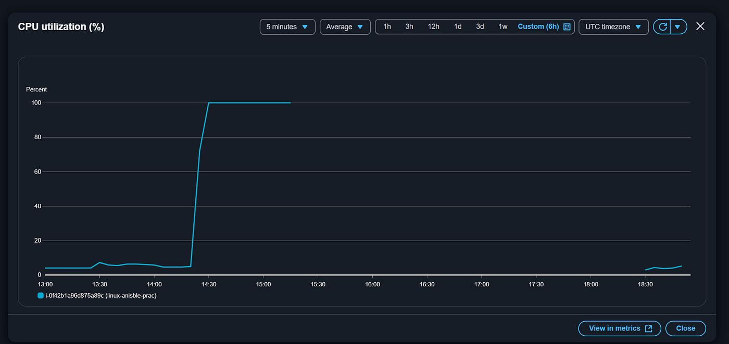
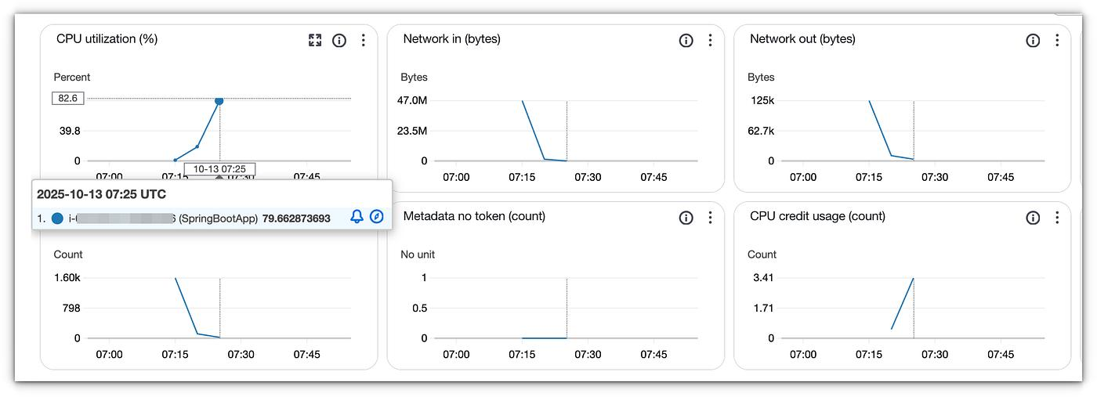
You should eventually see something resembling:
CPUUtilization (%)

100 |
90 |
80 |
70 |------------------------- Alarm threshold
60 | ___
50 | / \
40 |_____/ \____
30 |
20 |
10 |
0 +--------------------------
Time →
Your important metric is:
CPUUtilization
This tells you how much CPU your EC2 instance is using.

3. CloudWatch alarm
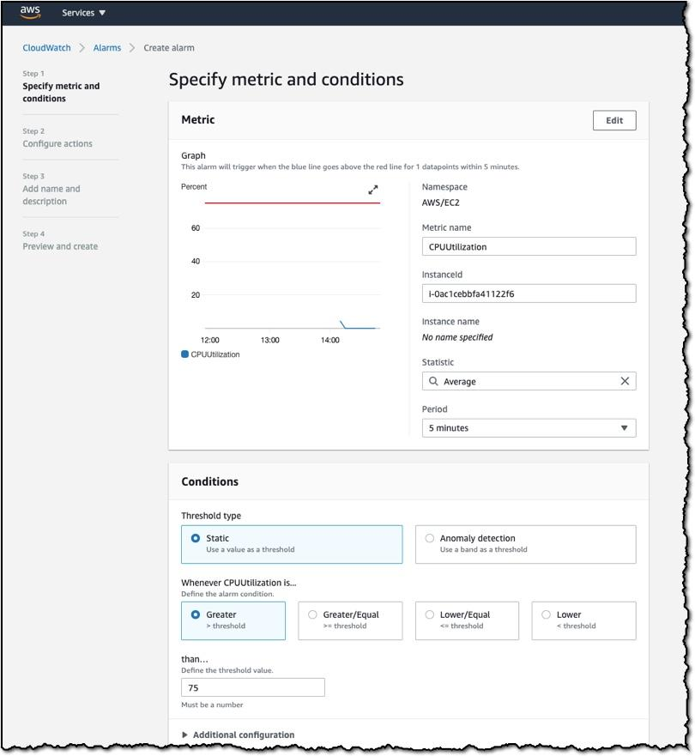
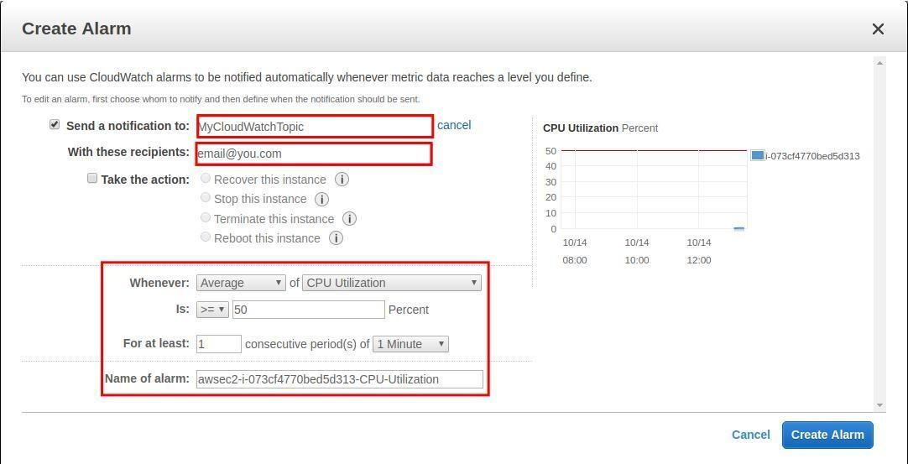
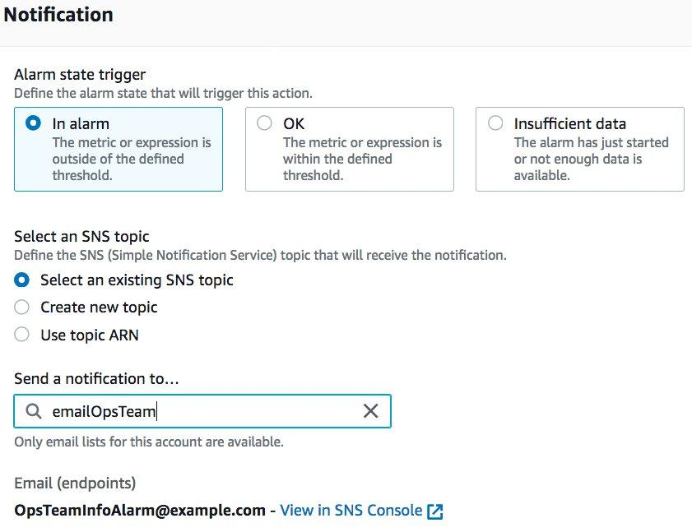
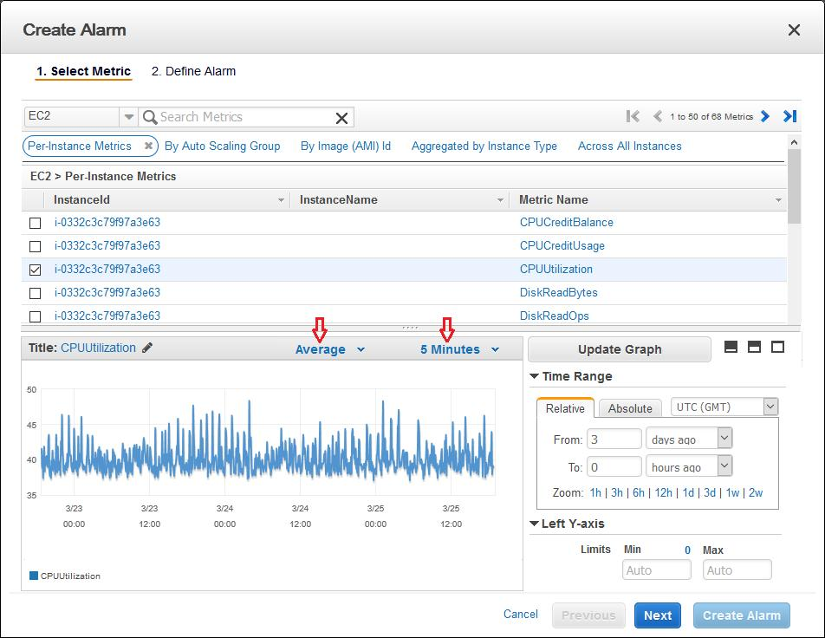
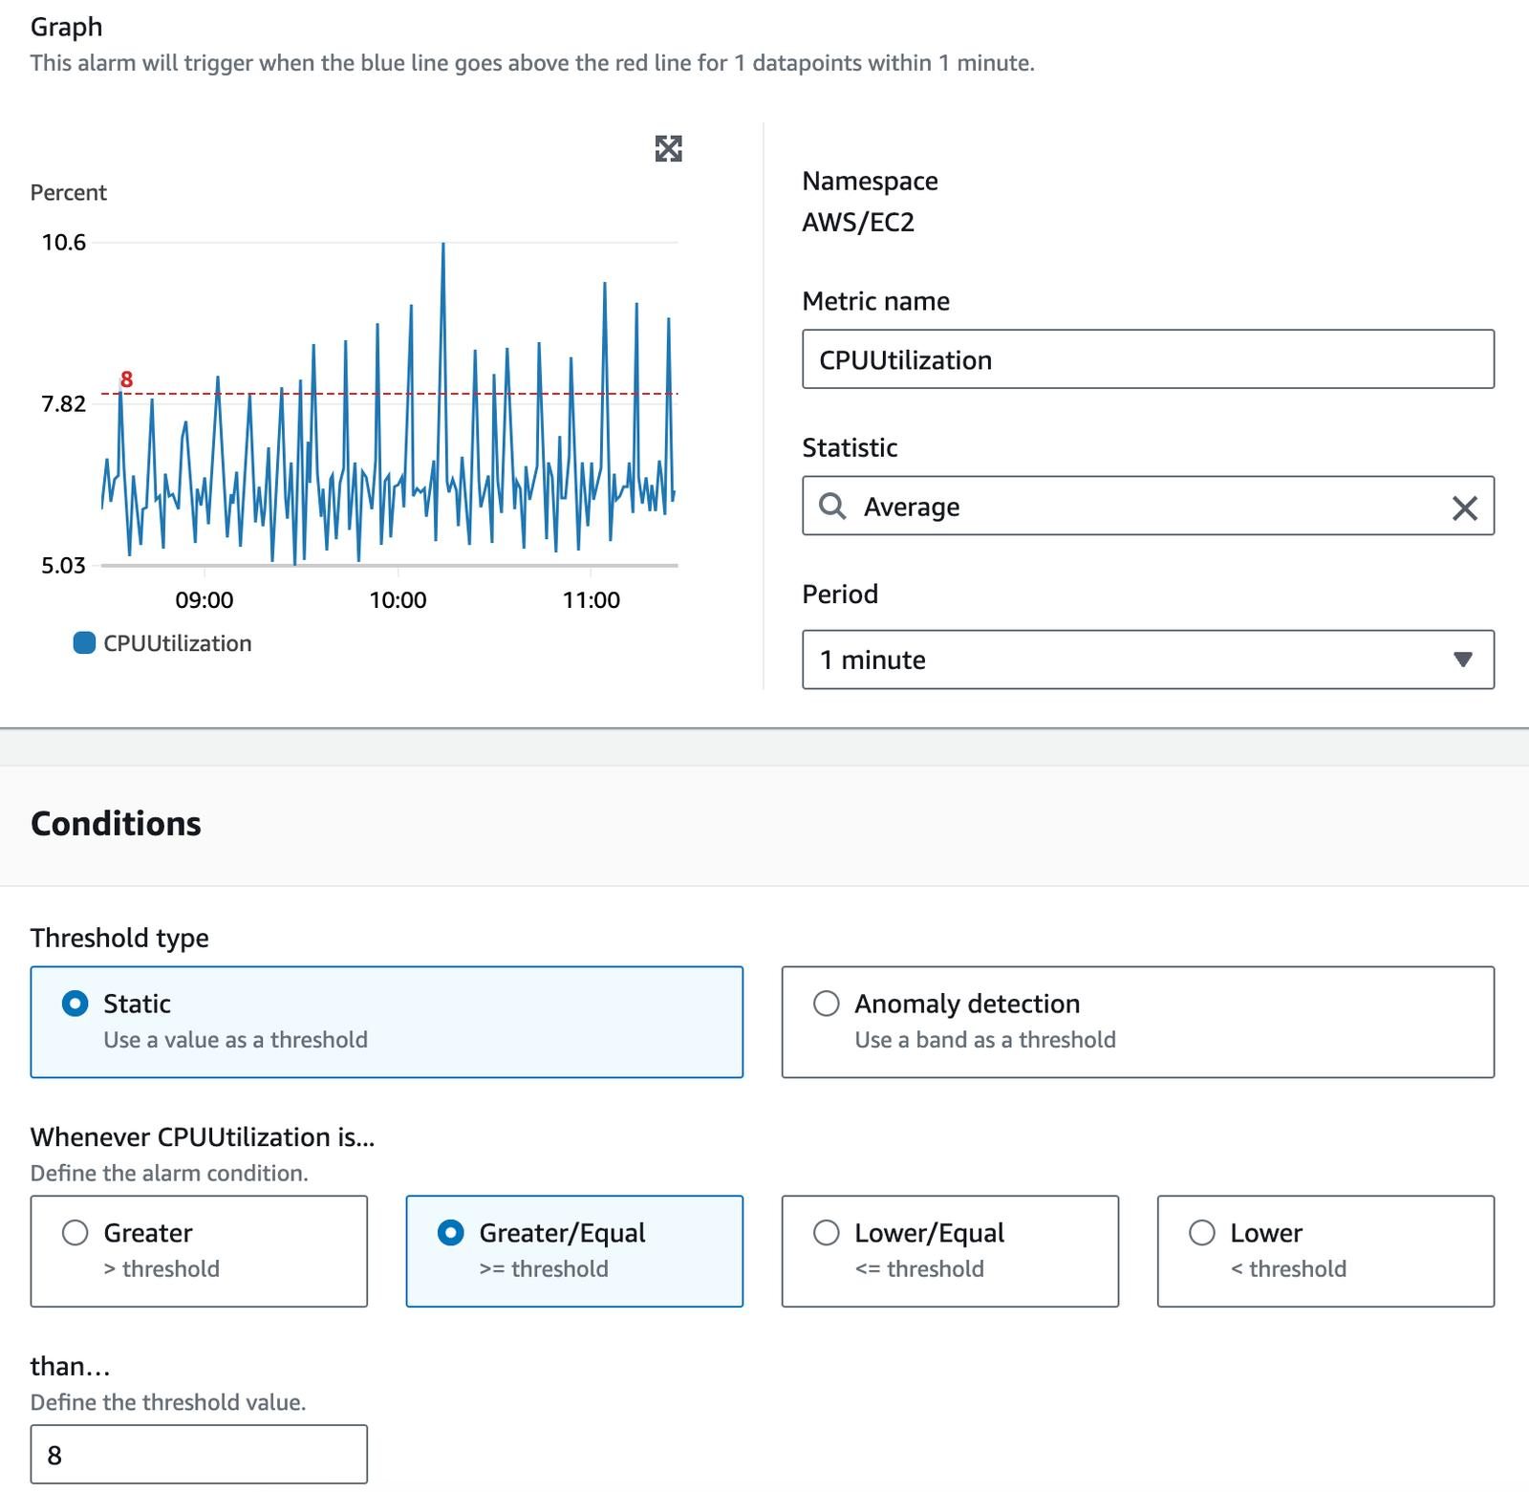
Your configuration should be approximately:
Metric: CPUUtilization
Statistic: Average
Period: 5 minutes
Condition: Greater than
Threshold: 70%
Action: Send notification
So AWS is basically being told:
"If CPU utilization stays above 70% for the specified 5-minute period, send me an email."
Example alarm status
EC2-CPU-Above-70

State: 🟢 OK
Later, during your CPU test:
EC2-CPU-Above-70

State: 🔴 ALARM

4. Email notification
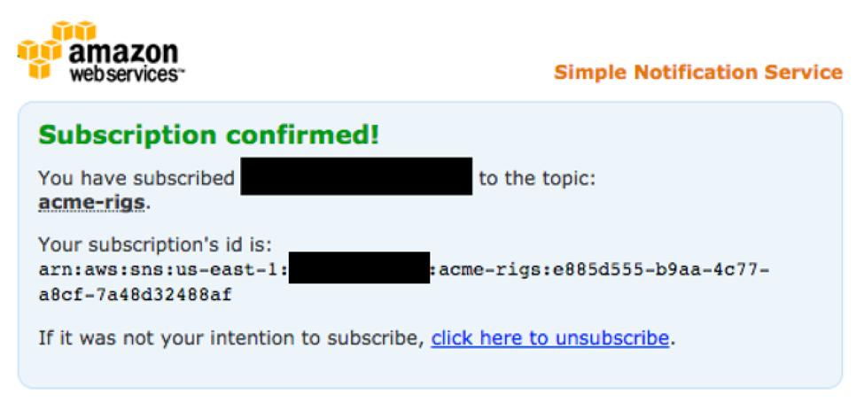
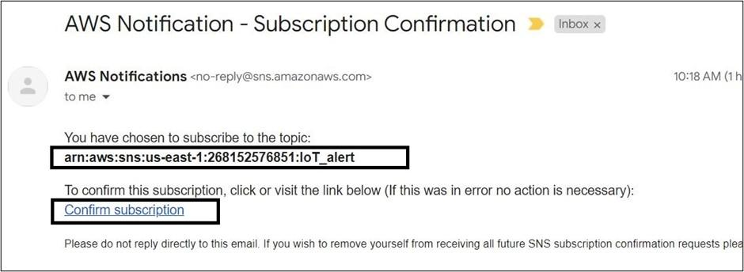
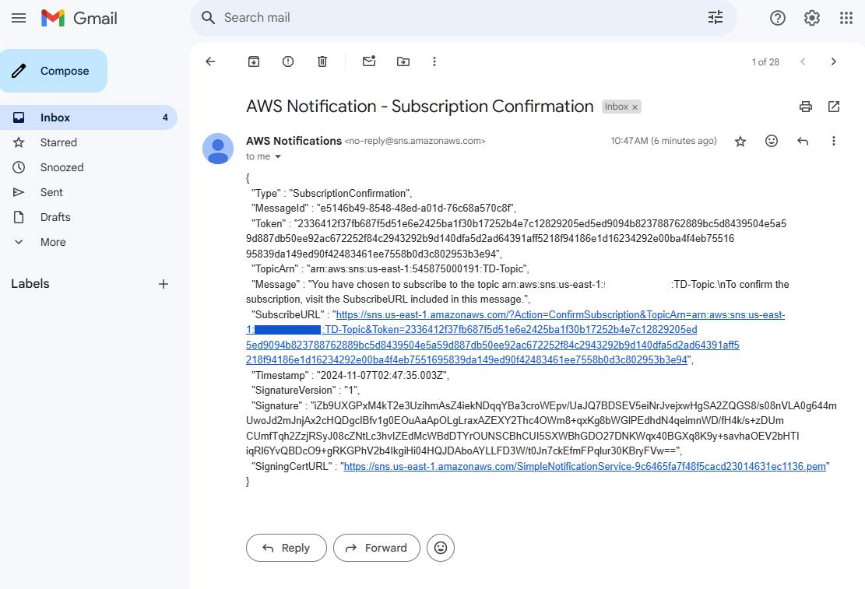
When you create the notification, AWS/SNS will send an email asking you to confirm the subscription.
Don't forget to click the confirmation link.
Otherwise, your CloudWatch alarm may enter the alarm state but the email won't reach you.

5. CPU spike
For this part, you'll connect to your Linux EC2 instance.
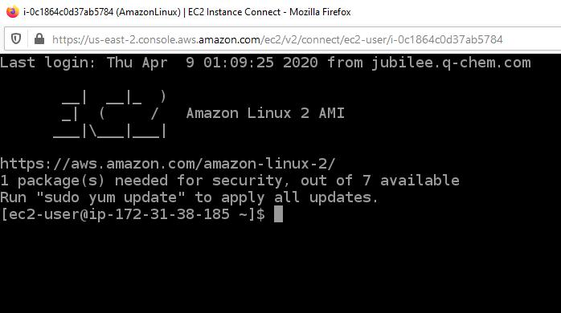
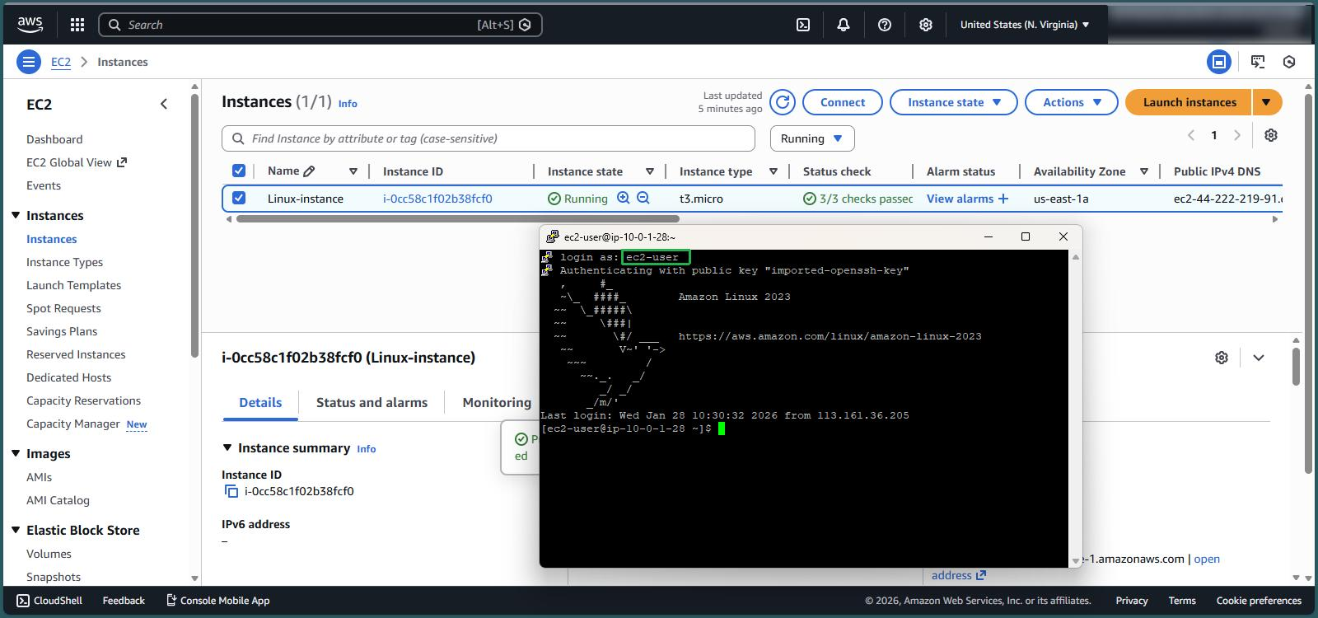
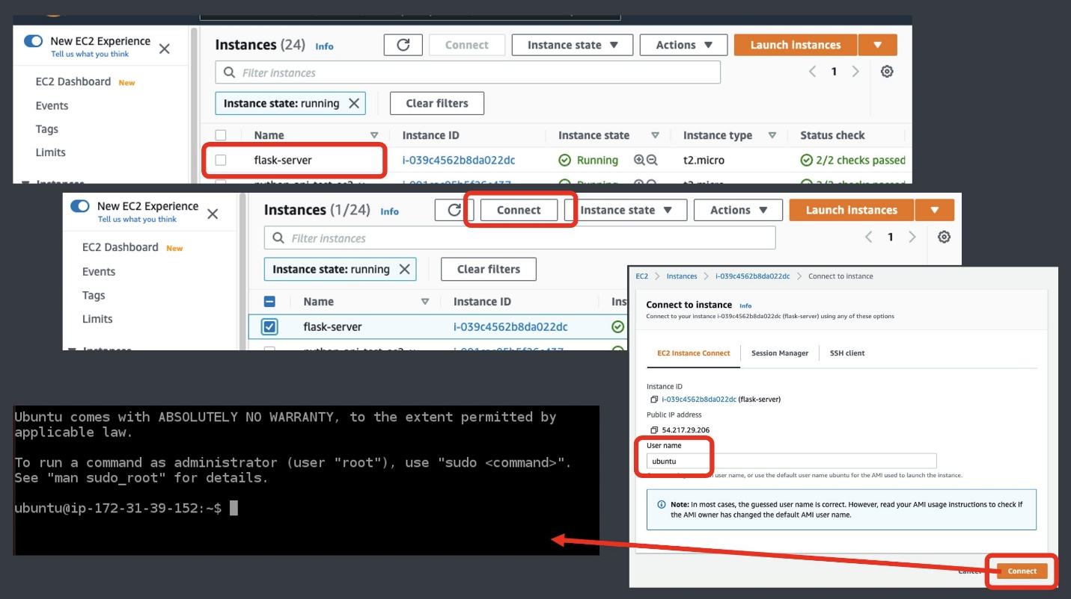
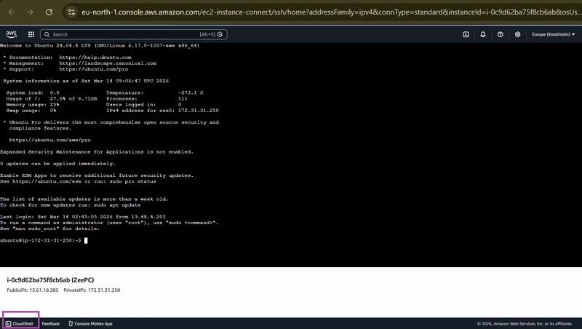
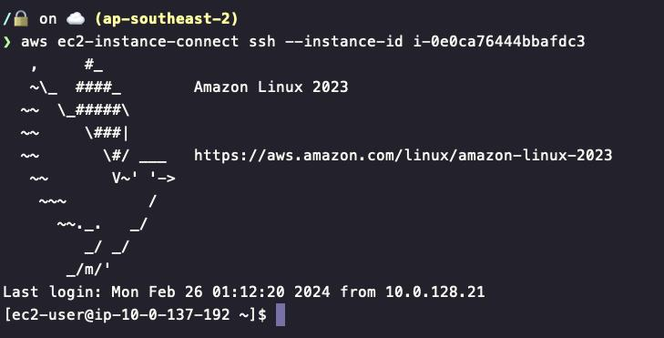
Run:
while true; do :; done
Before:
CPU utilization
↓

10%
_______/\________________
After running the command:
CPU utilization
↓

90%
/\
/ \
___________/ \________
Eventually CloudWatch should show the increase.
When finished, press Ctrl + C to stop the CPU load.

6. Azure Storage Metrics
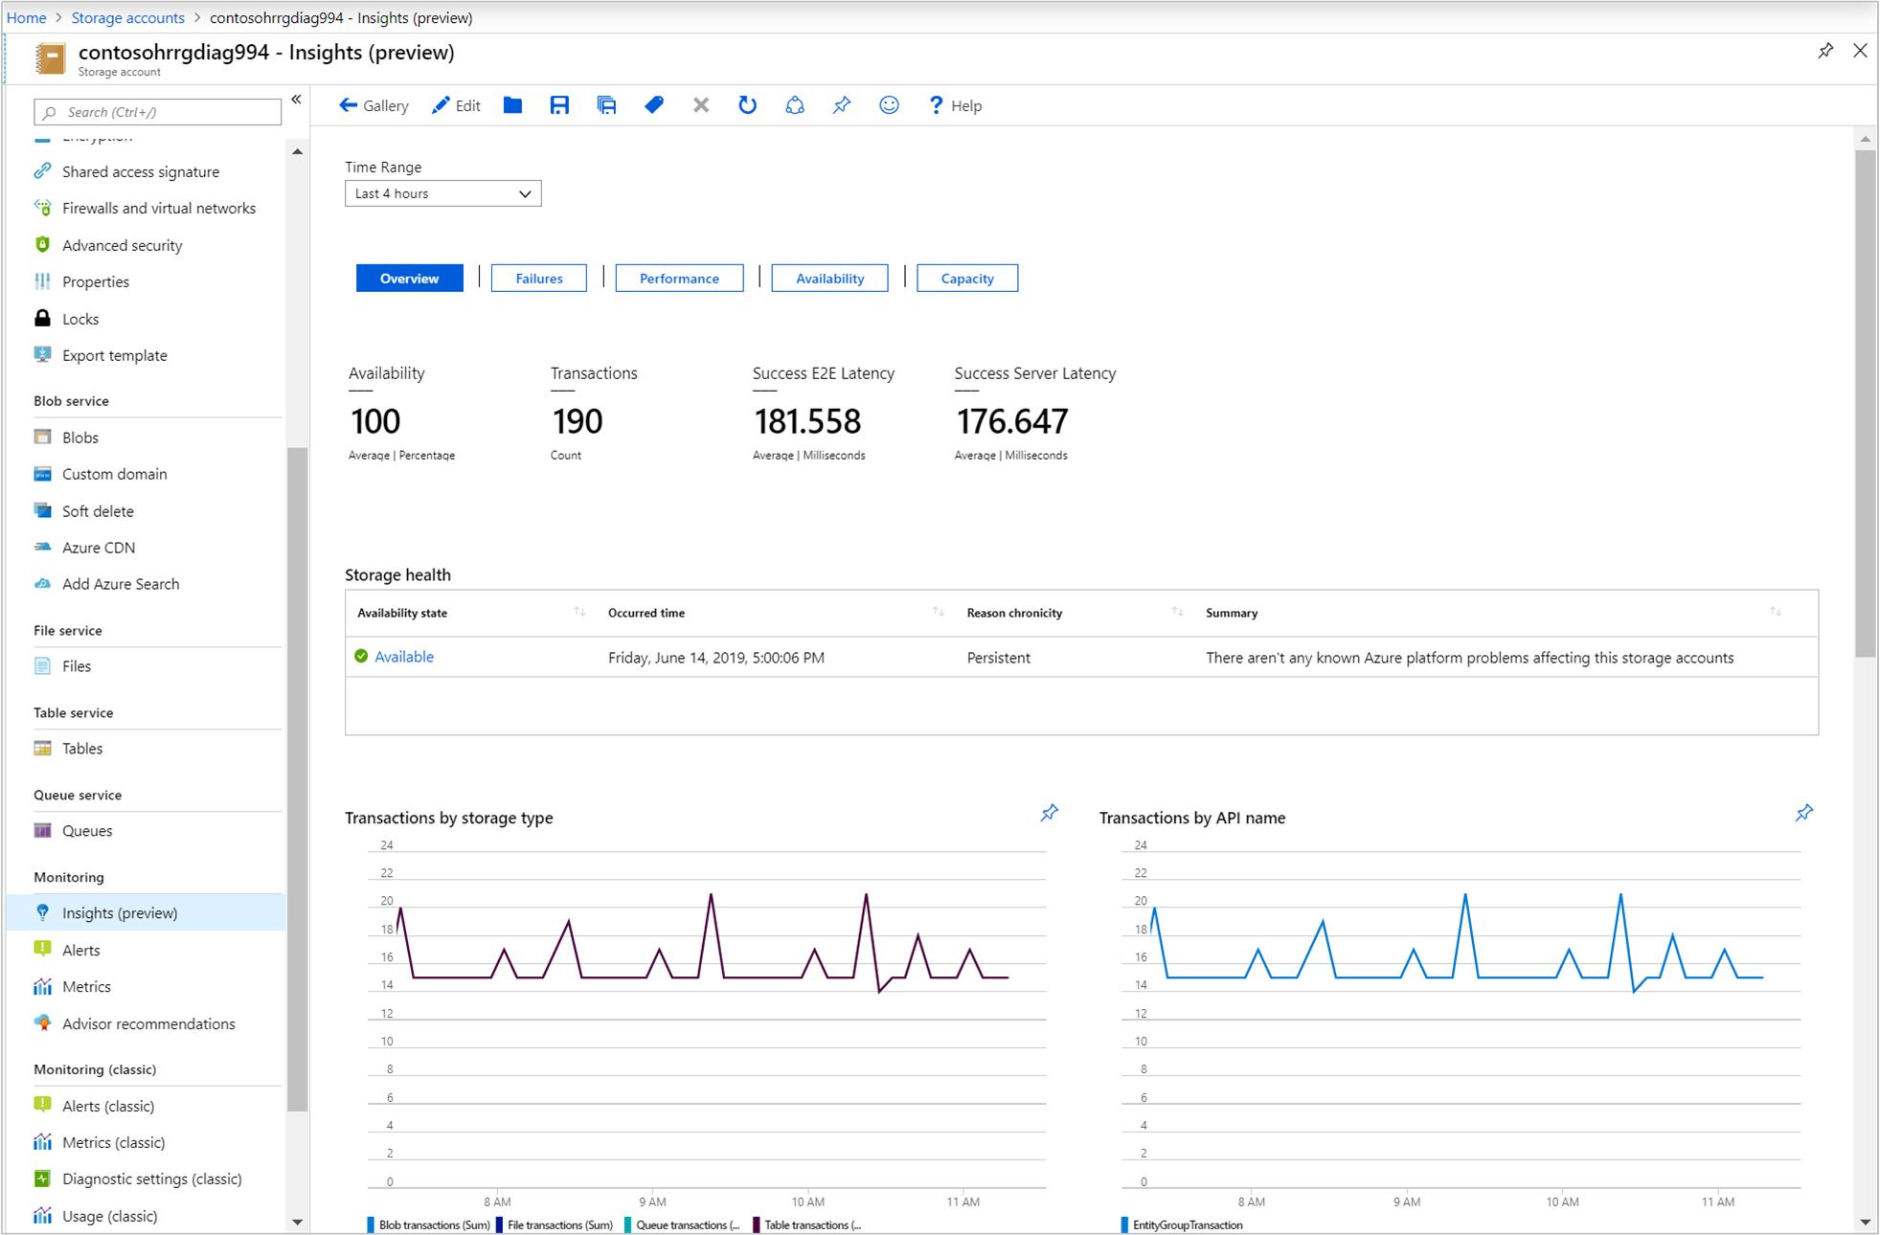
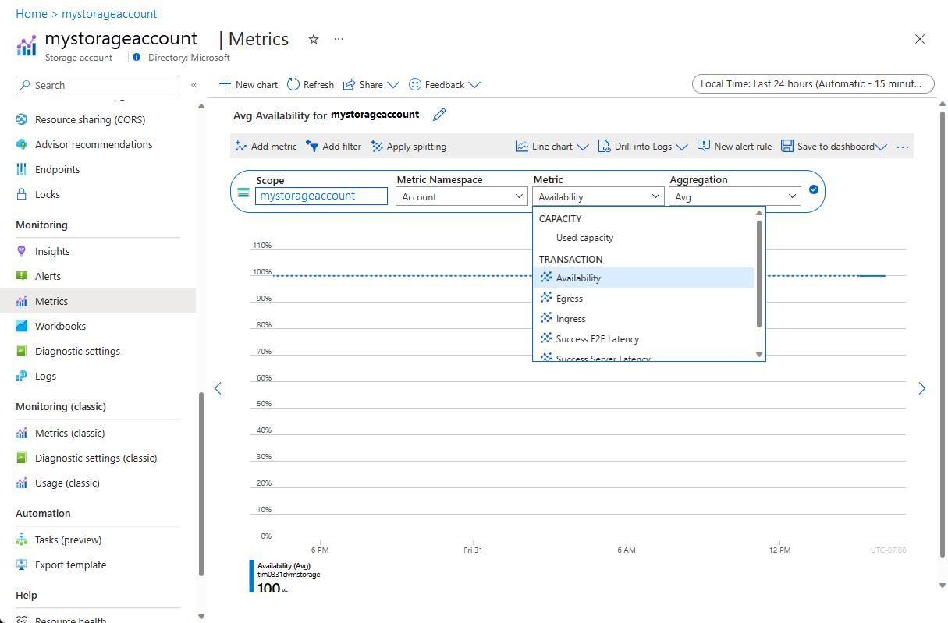
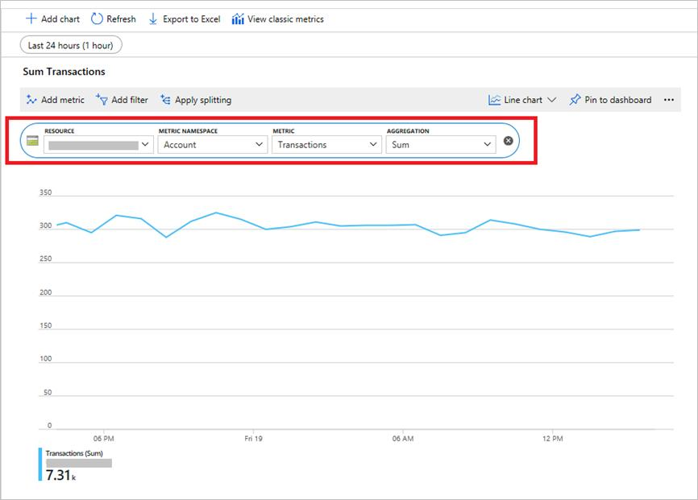
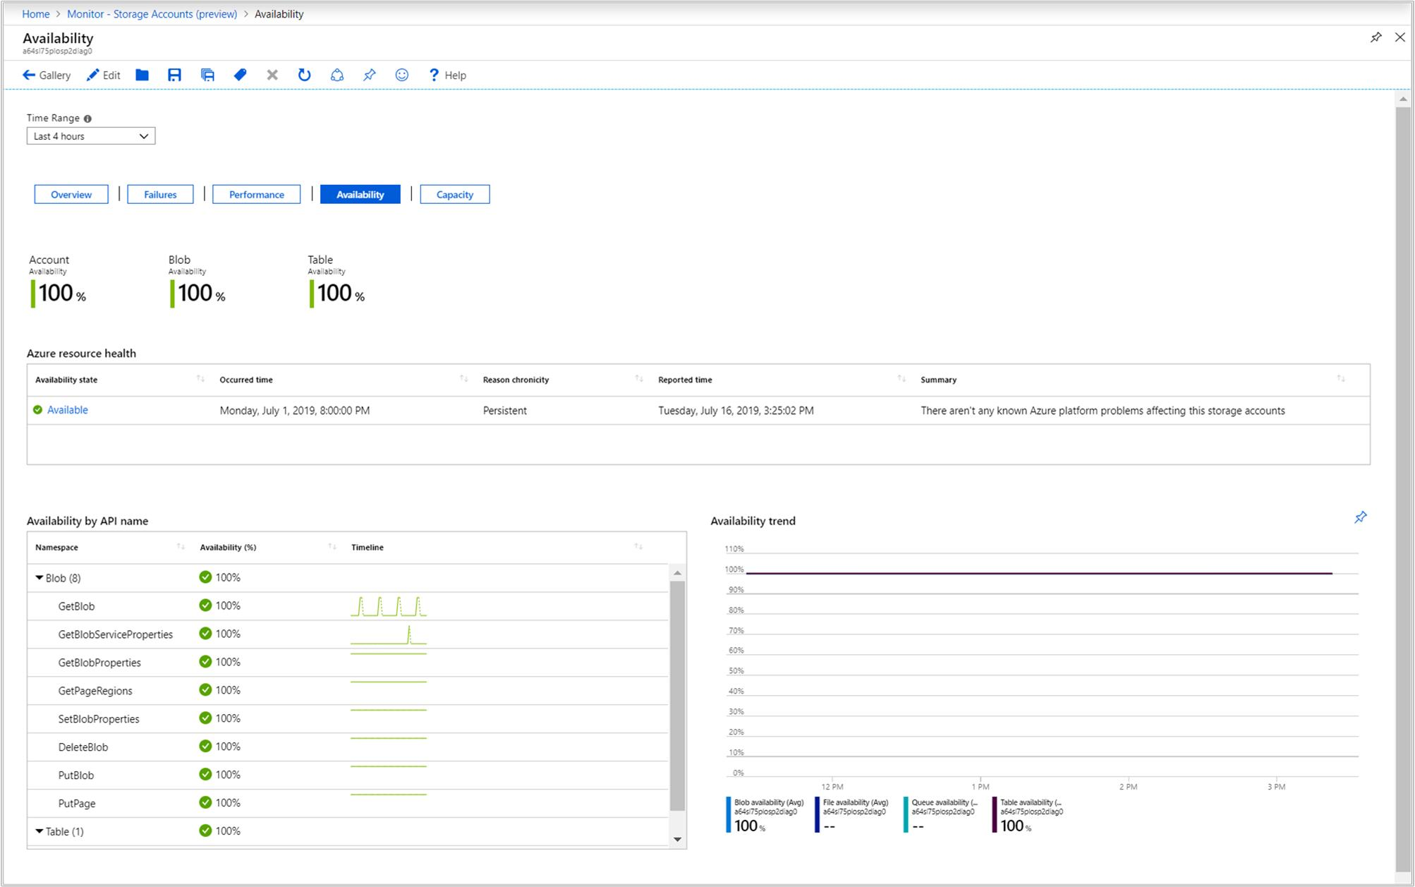
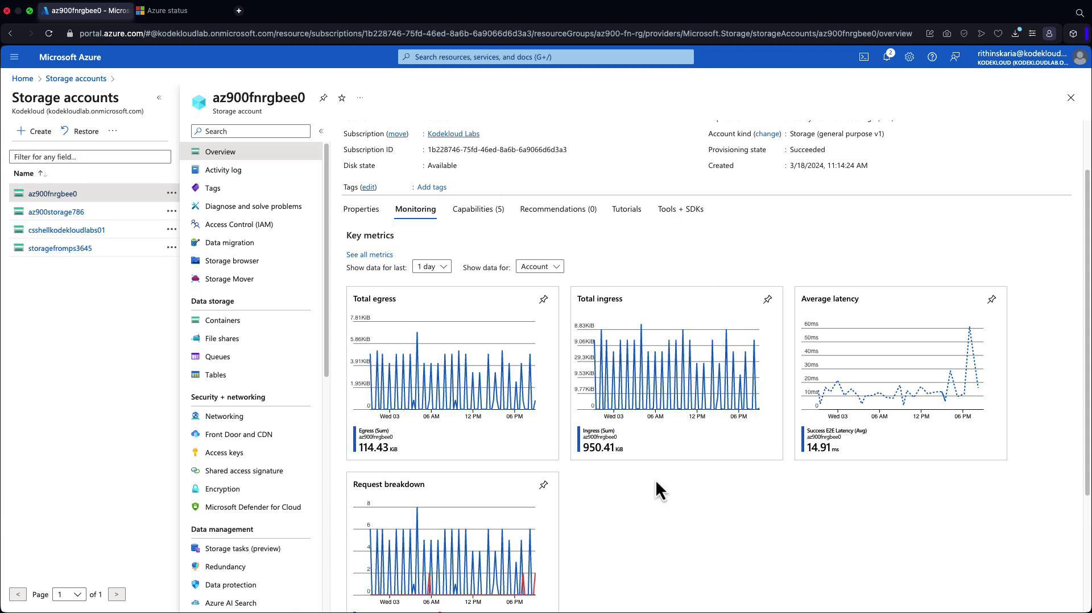
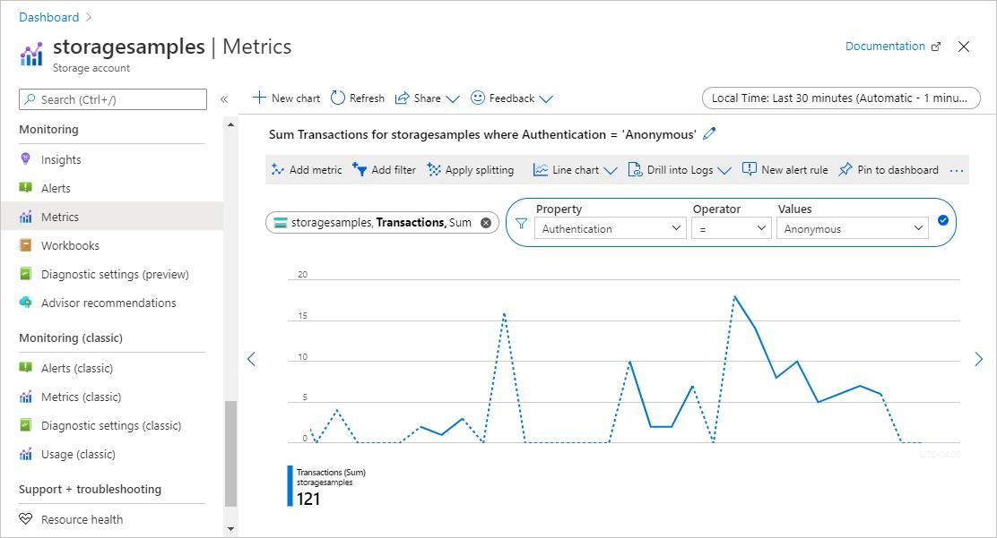
You want to reach:
Azure Portal → Storage Account → Monitoring → Metrics
Then select metrics such as:
Metric:
✓ Total Requests
✓ Availability
You should see a graph similar to:
Requests

100 | /\
80 | / \
60 | ____/ \
40 |_____/
20 |
0 +--------------------
Time →

⭐ What screenshots should you submit?
I'd take 5–6 screenshots:

Screenshot 1 — EC2
Show:
CloudWatch-Demo
t2.micro
Running

Screenshot 2 — CloudWatch
Show:
CPUUtilization
with the graph visible.

Screenshot 3 — Alarm
Show:
CPUUtilization
> 70%
5 minutes
Send notification

Screenshot 4 — Email
Show the AWS/SNS notification/confirmation.

Screenshot 5 — CPU spike
Show CloudWatch with CPU increasing significantly.

Screenshot 6 — Azure
If you're doing Task 3, show:
Azure Storage Account
→ Metrics
→ Total Requests / Availability

💡 Tip
If you're doing this assignment right now, don't try to complete everything at once.
Start with Task 1. Once you've launched the EC2 instance, send me a screenshot of what you're seeing on the AWS page, and I can tell you exactly where to click next.

